Tutorial On
Store Vehicle Sensor Data in MongoDB
Big Data - Part 1

Document Revision and Approval History

Title: User Manual on Storing Vehicle Sensor Data into MongoDB

ID :

Effective: 03-June-2014
Edition No. | Release Date | Author’s Name | Software Version | Reason for Change / Description of Changes
1 | 06/06/2014 | Praneeth | Mongo 2.6.4
2 | 05/10/2014 | Praneeth | Mongo 2.6.4
3 | 03/11/2014 | Praneeth | Mongo 2.6.4
4 | 19/02/2015 | Manish

About
In this practical you will use MongoDB as a data store to store the time series data that is being streamed from the devices fixed on the cold chain vehicles via web services. [Note: We will do the practical on web services after this]. This tutorial will give you an hands on experience on connecting with a NoSQL system like MongoDB, understand its API and structure of storing information as well as steps to store and retrieve information from MongoDB.
Table of Contents

- Objective
- End-End IOT Tutorial flow
- Steps
- Introduction about MongoDB
- Get MongoDB Server status
- Write queries on MongoDB
- What is collection and how to create collection
- Sample Queries

- Objective:
- Gives you hands-on experience on MongoDB
- Helps you learn how to store data in MongoDB and
- How to query data from it

- End-End Practical flow:

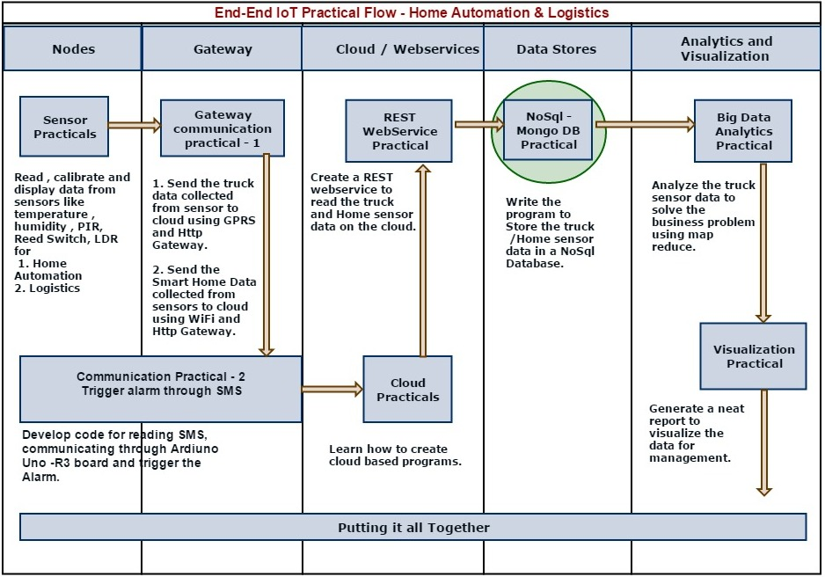

- Practical flow:

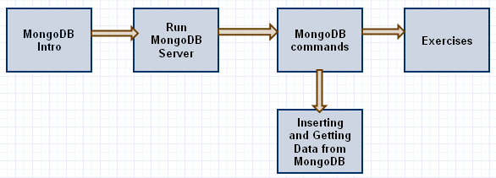

- MongoDB Introduction:

- Big data is data that exceeds the processing capacity of conventional database systems like
Mysql, Oracle, SQL Server etc.
- To deal with Big data we have NoSQL solutions’ which can store bulk data.
- MongoDB (from "humongous") is a cross-platform document-oriented database, classified as a NoSQL database.
- MongoDB eschews the traditional table-based relational database structure in favour of JSON-like documents with dynamic schemas (MongoDB calls the format BSON), making the integration of data in certain types of applications easier and faster.

Features:
- Document-oriented :
Instead of taking a business subject and breaking it up into multiple relational structures, MongoDB can store the business subject in the minimal number of documents.
For example, instead of storing title and author information in two distinct relational structures, title, author, and other title-related information can all be stored in a single document called Book, which is much more intuitive and usually easier to work.

- Ad hoc queries :
MongoDB supports search by field, range queries, regular expression searches. Queries can return specific fields of documents and also include user-defined JavaScript functions.

- Load balancing:
MongoDB can run over multiple servers, balancing the load and/or duplicating data to keep the system up and running in case of hardware failure. Automatic configuration is easy to deploy, and new machines can be added to a running database.

- Aggregation
MapReduce can be used for batch processing of data and aggregation operations. The aggregation framework enables users to obtain the kind of results for which the SQL GROUP BY clause is used.

- Server-side JavaScript execution
JavaScript can be used in queries, aggregation functions (such as MapReduce), and sent directly to the database to be executed.

5. Get Mongo Server Status:

- MongoDB server is already deployed and is running on this virtual machine. By default it operates on port 27017 and provides an REST API interface to access it. You can download and install MongoDB from the following location - https://www.mongodb.org/downloads on your work machine at a later stage.

6. Write queries on MongoDB:

MongoDB can also be accessed through mongo command line interface.
Open command [cmd] prompt and run mongo command to connect to the server. Check the below screen for reference

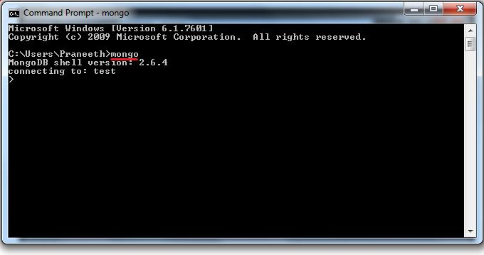

- Once you are done with above step you can fire the queries on mongo
- Command: show dbs
Description: To display list of databases. Databases are like schema from relational data base concept point of view.
Example: show dbs

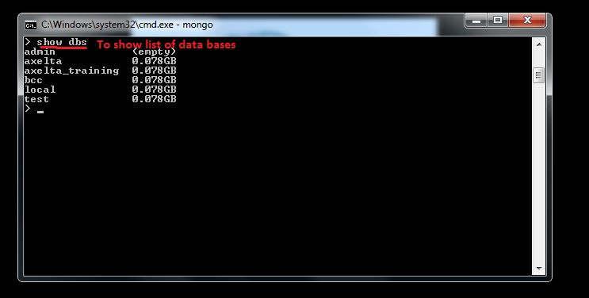

Creating new database in Mongo

- Command: use <dbname>
Description: To switch to an existing database
Example: use bcc1

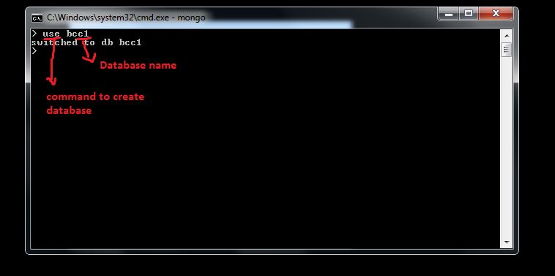

7. What is a Collection and how to create it

- A MongoDB deployment hosts a number of databases. A database holds a set of collections.
- Collection holds a set of documents. A document is a set of key-value pairs.
- Documents have dynamic schema. Dynamic schema means that documents in the same collection do not need to have the same set of fields or structure, and common fields in a collection’s documents may hold different types of data.
- The purpose of creating collections is separate out completely different data structures or business elements from each other. So that the querying and processing gets faster.

7.1 Creating a new collection on MongoDB

- Once we done with creating data base its mandatory to create collection to store data

Command: db.createCollection("<collection name>")
Description: to create collection
Example: db.createCollection("transactions")

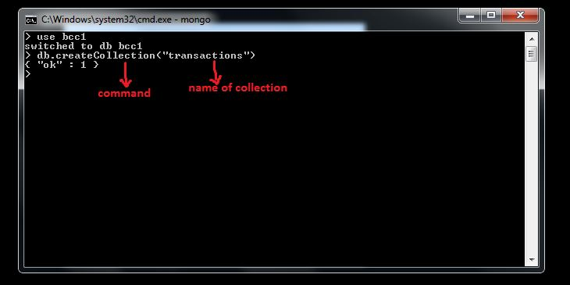

In our case "transactions" collection is intended to store time series data coming from the vehicles. Following is an example of how individual document in this collection looks like

{
"door_operation" : "Close",
"client_key" : "oWj7tA",
"device_type" : "Cold Chain",
"type" : "transaction",
"moving_status" : false,
"temperature" : -23,
"timestamp" : 1388635320,
"trip_id" : 1,
"device_key" : "FRD56284NQ5HT5CYV3C1",
"humidity" : 45,
"device_no" : "BCC1",
"longitude" : 85.06001,
"latitude" : 25.63572,
"node_no" : "001",
"power_status" : false
}

- We can create any number of collections in data base. Another collection required for our use case is "trips". Trips collection represents the meta data for each trip.
- To explain further there will be a "trip" from Delhi to Bangalore. It will contain information like who is the driver, what is the vehicle name, what is the material being carried, start date and time, etc.
- For each of these there will be multiple transactions that represents the data being sent by the IoT device fitted on the vehicle on a regular basis.

Command: db.createCollection("trips")

8. Sample Queries:

- Display list of collections
Command: show collections
Description: To Display list of collections

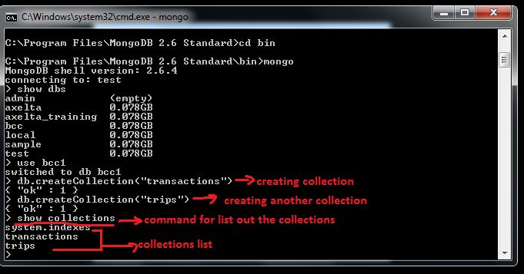

- Inserting data into collection
Command: db. <Collection>.insert(Json)
Description: Inserting data into collection
Example: 
db.transactions.insert({
"door_operation" : "Close",
"client_key" : "oWj7tA",
"device_type" : "Cold Chain",
"type" : "transaction",
"moving_status" : false,
"temperature" : -23,
"timestamp" : 1388635320,
"trip_id" : 1,
"device_key" : "FRD56284NQ5HT5CYV3C1",
"humidity" : 45,
"device_no" : "BCC1",
"longitude" : 85.06006000000001,
"latitude" : 25.63572,
"node_no" : "001",
"power_status" : false
})

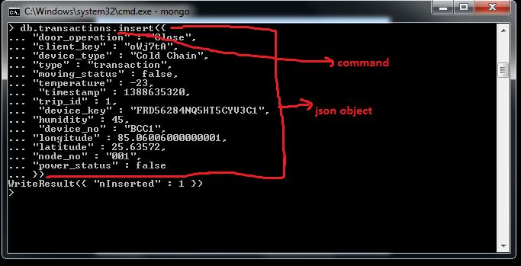

- View the stored data
Command: db.collection_name.find()
Example: db.transactions.find()

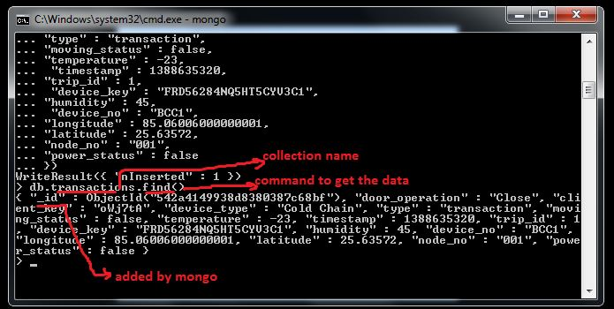

_id Field :
If the document does not specify an _id field, then MongoDB will add the _id field and assign a unique ObjectId for the document before inserting.
- To format the result, you can add the .pretty() to the operation, as in the following:
Command: db.<collection>.find().pretty()
Example: db.transactions.find().pretty()
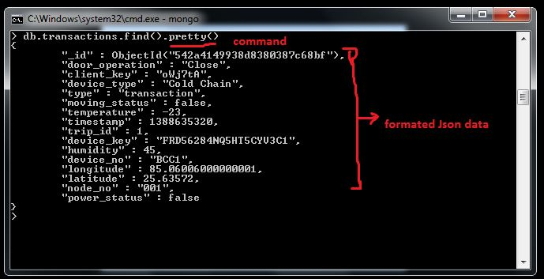
- Insert data into "trips" collection
Example : 
db.trips.insert({
"_id" : 1,
"end_location" : "Lucknow",
"minimum_humidity" : 40,
"end_timestamp" : 1388679900,
"driver_name" : "Ram",
"minimum_temperature" : -23,
"start_location" : "Patna",
"start_latitude" : 25.611,
"customer" : "Aska Sea",
"material" : "Fish",
"maximum_temperature" : -18,
"start_longitude" : 85.144,
"maximum_humidity" : 50,
"device_no" : "BCC1",
"end_longitude" : 80.947,
"end_latitude" : 26.847,
"start_timestamp" : 1388634420,
"node_no" : "001"
})
More involved queries
Note: For writing select queries switch to bcc database as we don’t have much data in bcc1 database that we just created above. "bcc" database that is already created has a number of trip and transaction records that we will be using to perform detailed queries.
- Command: use <dbname>
Description: Switching from one database to another
Example: use bcc
Query:
- Objective: Get list of all trips where material is fish
Query: db.trips.find({material:"Fish"}).pretty()
Note: Here find command will do exact match (case sensitive)
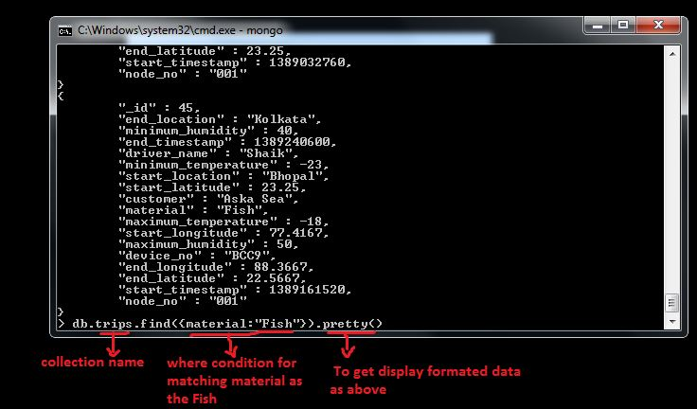

- Query : db.trips.find({material:/^fish$/i})
Description: To get records without case sensitive (you can pass fish or FISH or Fish etc…)

Query:
- Objective: Get all trips in between two dates
- The time format used to store data is epoch format so input times should be in same format
- Epoch time is the number of microseconds from a fixed start time which is "00:00:00 1 January, 1970" UTC
- Let’s take two dates and its equivalent epoch time

2014-01-02 , its equivalent epoch time is 1388601000
2014-01-04 , its equivalent epoch time is 1388773800

There are many online converters that can be used for doing the conversion to epoch time.
Date to epoch time conversion in java script
new Date("2014,01,04").getTime()/1000;

db.transactions.find({timestamp:{$lte: 1388773800,$gte: 1388601000}}).pretty();

$lte means less than or equal
$gte means greater than or equal

Summary: This completes the basic understanding for accessing MongoDB through command line interface, creating databases and collections, searching through different collections as well as querying collections to extract documents based on a criteria.
Further Learning: To consolidate the learning it is recommended that you download a MongoDB instance on your machine, configure it and do the same steps above.

********************************
Thank You

